Scenario 7: Cross-Region VPC Peering (Connect ap-south-1 VPC to us-east-1 VPC).
In this scenario, we connect two VPCs across different AWS regions:
- ap-south-1 (Mumbai)
- us-east-1 (N. Virginia)
Purpose:
Allow an EC2 instance in us-east-1 to privately communicate with an EC2 instance in ap-south-1 using private IP addresses.
No NAT, no VPN, no IGW — only inter-region VPC peering.
Step 1: lets create instance in us-east -1 region under default VPC and let’s try to access that from our region ap-south-1c
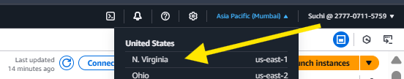
Step 2: go to VPC .
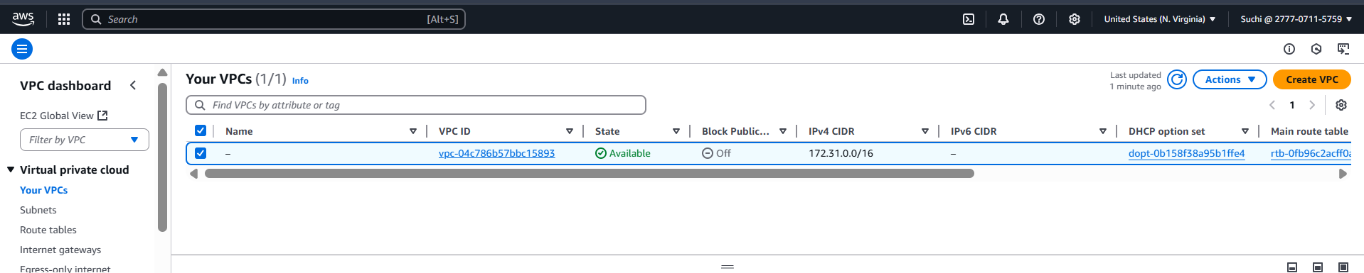
Step 3: lets create and peering connections.
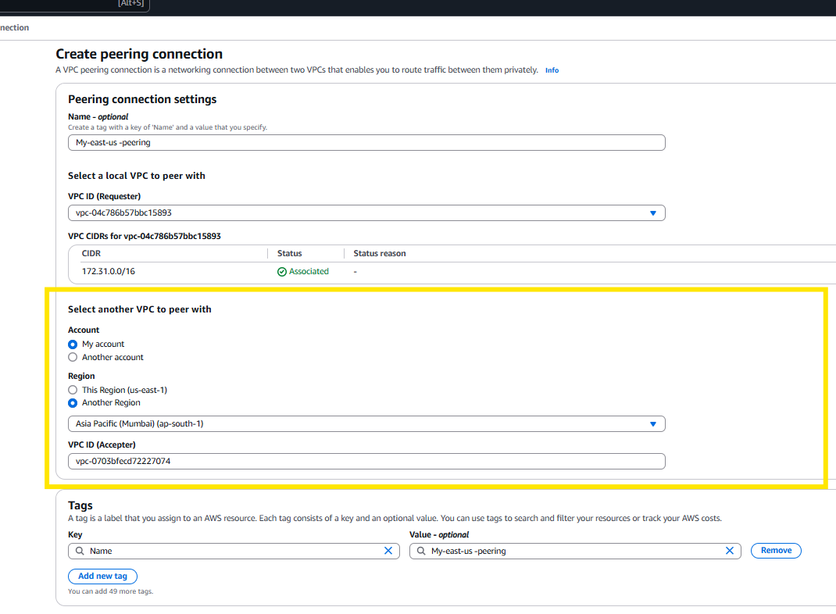

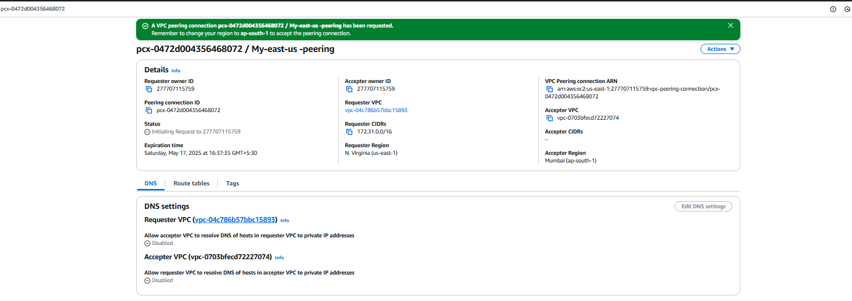
Step 4: lets accept the invite. Go back to ap-south-1c region and go to peering connections under VPC.
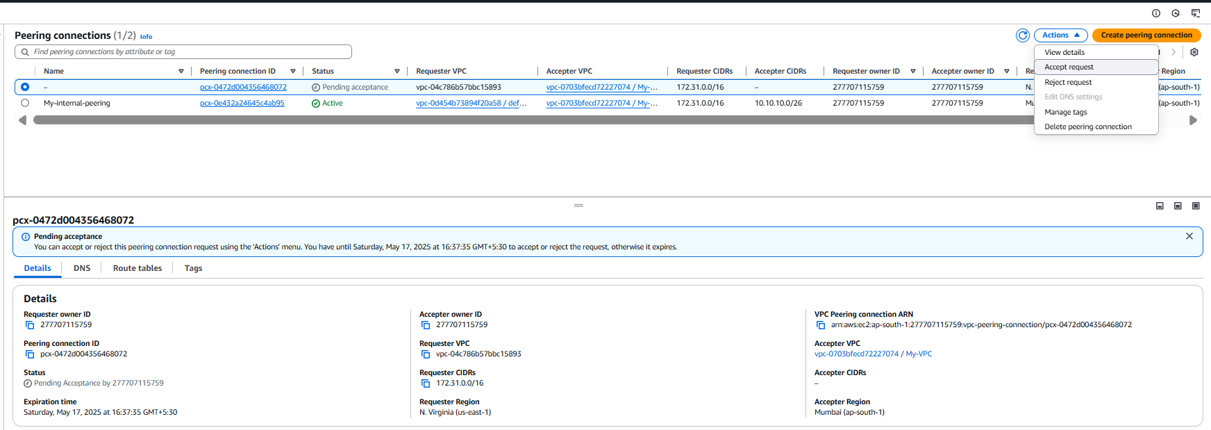
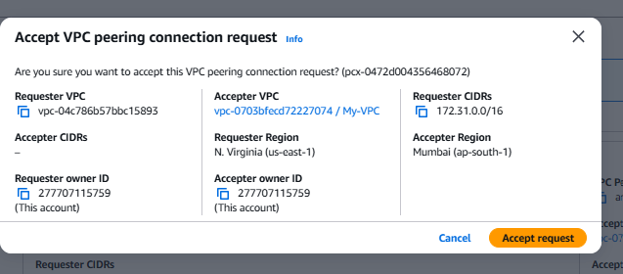
Step 5: edit the route table.
Go back to us-east-1 region and click on route table under VPC.
Edit the exciting route table.
Destination: ap-south VPC CIDR (10.10.10.0/24 → pcx-xxxxxxxx)
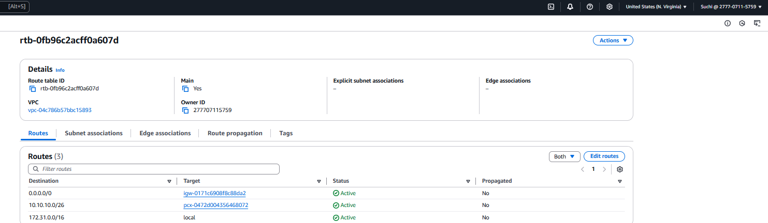
Do the same for ap-south-1 , private-RT . add east-us CIDR
Destination: us-east-1 VPC CIDR (172.31.0.0/16 → pcx-xxxxxxxx)
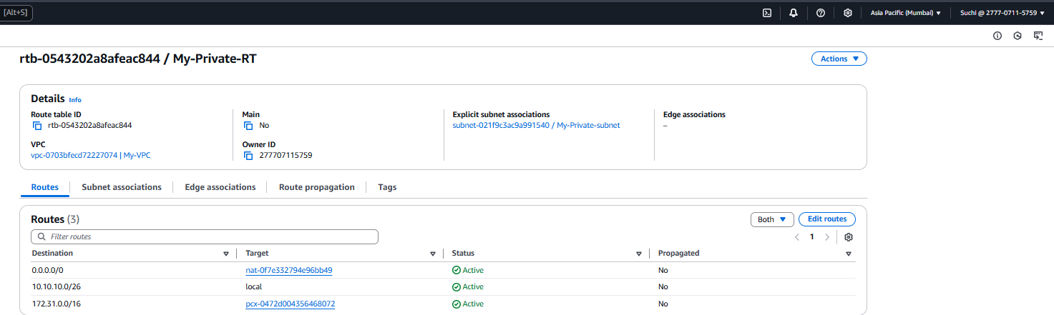
Step 6: lets create an instance in east-us and try to connect to ap-south private server.
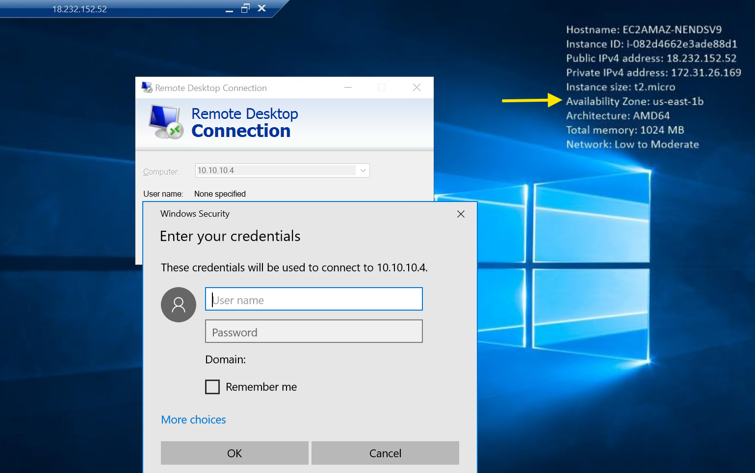
Step 8: you can also check ping connections for validation.

